TECHNICAL DOCUMENTATION
Fescom AI Automation Platform
Multi-Agent System for UK Legal Services

Created by: Hassan Kamran (AI ENGINEER)

Prepared for: Fescom Tech360
Position: Senior AI Engineer (Agentic AI Specialist)
Date: January 2025

Abstract

Disclaimer:
For the purpose of this document and purely as an assumption, the organization has been referred to as Brightlaw. Any references to Brightlaw are hypothetical and used solely to illustrate the design and implementation of the Agent-to-Agent Cloud-Based Solution for Managing Lawyers’ Workflows. This does not imply any association with, endorsement by, or representation of any real organization.
This document presents a comprehensive AI-powered automation solution designed to address the operational scaling challenges faced by BrightLaw, a mid-sized UK legal services firm. The platform employs a multi-agent architecture where specialized AI agents collaborate to automate routine administrative tasks that currently consume significant lawyer time.
The solution handles four primary input channels: emails, voice calls (transcribed), website chat conversations, and document uploads. Each input is processed by specialized AI agents that classify, extract information, identify deadlines, and generate appropriate responses. The system includes a human-in-the-loop design ensuring lawyers maintain oversight of all AI decisions.
The cloud-native architecture using Google Cloud Pub/Sub and serverless computing enables the system to scale automatically to handle high volumes of incoming requests while remaining cost-efficient during quiet periods.

1. Problem Statement
"Lawyers at BrightLaw spend 60% of their working hours on repetitive administrative tasks instead of providing legal advice. Reading emails, sorting documents, extracting deadlines, and drafting routine responses consumes valuable time that could be spent on billable client work. As the firm grows, these manual processes become a bottleneck that prevents scaling."

1.1 The Core Challenge
BrightLaw is a mid-sized UK legal firm with 50 employees serving approximately 800 clients across corporate law, employment law, and property law. The firm receives communications through multiple channels daily:
- 100+ emails requiring reading, classification, and response
- Phone calls that need to be logged and actioned
- Website chat inquiries from potential clients
- Legal documents requiring review, classification, and deadline extraction
Each of these tasks currently requires manual human processing, creating a linear relationship between workload and staff requirements. This means the firm cannot grow without proportionally increasing headcount.

2. The Solution: AI Agent Automation

2.1 Core Concept
"The redundant tasks that consume lawyer time can be automated using AI agents. Each repetitive task is handled by a specialized AI agent that works 24/7 without fatigue."

2.2 Tasks That Can Be Automated
We identified the following repetitive tasks that are suitable for AI automation:
Task | What the AI Agent Does
Email Classification | Reads emails, identifies intent (new matter, status inquiry, complaint), extracts client info, determines urgency
Document Classification | Identifies document type (contract, court filing, etc.), extracts parties, dates, key terms, flags important clauses
Deadline Extraction | Finds all dates in documents/emails, calculates limitation periods, creates reminders
Response Drafting | Generates professional draft responses for lawyer review before sending
Voice Call Processing | Transcribes calls, extracts key information, creates case summaries
Chat Inquiry Handling | Processes website chat conversations, identifies practice area, assesses urgency

2.3 One Agent Per Task
Rather than building one large AI system, we create specialized agents for each task. This approach has several advantages:
- Each agent is an expert in its specific domain
- Agents can be updated independently without affecting others
- If one agent fails, others continue working
- New agents can be added as new automation needs arise

3. The Agentic Architecture

3.1 Handling the AI Limitations
There are technical challenges that our architecture addresses:

Challenge 1: Large Documents
"AI models have a limited context window - they cannot read very long documents in one go."
Solution: We use a RAG (Retrieval-Augmented Generation) system. Documents are split into chunks and stored in a vector database. When the AI needs information, it retrieves only the relevant chunks rather than processing the entire document.

Challenge 2: Multiple Input Types
"Communications arrive as emails, voice calls, chat messages, and documents - all different formats."
Solution: We create specialized agents for each input type. Each agent understands its specific format and extracts structured information that can be processed consistently.

Challenge 3: Coordination
"With multiple agents, someone needs to decide which agent handles which task."
Solution: We have an Orchestrator Agent (supervisor) that receives all incoming requests and routes them to the appropriate specialized agent.

3.2 System Architecture

┌─────────────────────────────────────────────────────────────────────────────┐
│ CLIENT TOUCHPOINTS │
│ ┌──────────┐ ┌──────────────┐ ┌────────────────┐ ┌──────────────────┐ │
│ │ Email │ │ Web Portal │ │ Phone/Voicemail│ │ Document Upload │ │
│ │ Inbox │ │ (Chat) │ │ (Transcribed) │ │ (PDF/DOCX) │ │
│ └────┬─────┘ └──────┬───────┘ └───────┬────────┘ └────────┬─────────┘ │
└───────┼───────────────┼──────────────────┼────────────────────┼─────────────┘
└───────────────┴────────┬─────────┴────────────────────┘
▼
┌─────────────────────────────────────────────────────────────────────────────┐
│ MESSAGE QUEUE (Google Cloud Pub/Sub) │
│ Handles high-volume requests with automatic load balancing │
└─────────────────────────────────────┬───────────────────────────────────────┘
▼
┌─────────────────────────────────────────────────────────────────────────────┐
│ AI ORCHESTRATION LAYER │
│ ╔═══════════════════════════════════╗ │
│ ║ ORCHESTRATOR AGENT ║ │
│ ║ (Supervisor - Routes Tasks) ║ │
│ ╚═══════════════════╦═══════════════╝ │
│ ┌─────────────┬─────────────┬─────┴─────┬─────────────┬────────────┐ │
│ ▼ ▼ ▼ ▼ ▼ ▼ │
│ ┌─────────┐ ┌──────────┐ ┌─────────┐ ┌─────────┐ ┌─────────┐ ┌─────────┐ │
│ │ EMAIL │ │ DOCUMENT │ │ CLIENT │ │DEADLINE │ │RESPONSE │ │ CHAT │ │
│ │ TRIAGE │ │ CLASSIF. │ │ INTAKE │ │ TRACKER │ │GENERATOR│ │ HANDLER │ │
│ │ AGENT │ │ AGENT │ │ AGENT │ │ AGENT │ │ AGENT │ │ AGENT │ │
│ └─────────┘ └──────────┘ └─────────┘ └─────────┘ └─────────┘ └─────────┘ │
│ ▼ RAG System (Vector DB) ▼ │
│ Handles large documents by chunking & retrieval │
└─────────────────────────────────────┬───────────────────────────────────────┘
▼
┌─────────────────────────────────────────────────────────────────────────────┐
│ HUMAN-IN-THE-LOOP LAYER │
│ Cases flagged for lawyer review appear in Admin Dashboard │
└─────────────────────────────────────────────────────────────────────────────┘

4. Scalable Cloud Solution

4.1 The Scaling Challenge
"What happens when 100 emails arrive at once? Or when the firm grows to 2000 clients? The system must handle traffic spikes without crashing."

4.2 Cloud Architecture
We use Google Cloud Platform to ensure the system scales automatically:

┌─────────────────────────────────────────────────────────────────────────────┐
│ CLOUD SCALING ARCHITECTURE │
├─────────────────────────────────────────────────────────────────────────────┤
│ │
│ ┌─────────────┐ ┌─────────────┐ ┌─────────────┐ │
│ │ Request 1 │ │ Request 2 │ │ Request N │ ← High Volume │
│ └──────┬──────┘ └──────┬──────┘ └──────┬──────┘ Incoming │
│ │ │ │ │
│ └───────────────────┼───────────────────┘ │
│ ▼ │
│ ┌─────────────────────┐ │
│ │ Google Cloud │ │
│ │ Pub/Sub │ ← Message Queue │
│ │ (Load Balancing) │ Buffers requests │
│ └──────────┬──────────┘ │
│ │ │
│ ┌────────────────────┼────────────────────┐ │
│ ▼ ▼ ▼ │
│ ┌────────────┐ ┌────────────┐ ┌────────────┐ │
│ │ Agent │ │ Agent │ │ Agent │ ← Auto-scaling │
│ │ Instance 1 │ │ Instance 2 │ │ Instance N │ Serverless │
│ └────────────┘ └────────────┘ └────────────┘ (Cloud Run) │
│ │
│ ✓ Handles traffic spikes automatically │
│ ✓ Scales to zero when idle (cost efficient) │
│ ✓ Multi-threaded parallel processing │
│ │
└─────────────────────────────────────────────────────────────────────────────┘

Key Components:
- Pub/Sub Message Queue: Buffers all incoming requests. If 100 emails arrive simultaneously, they queue up and are processed in order. No requests are lost.
- Auto-scaling Serverless (Cloud Run): Automatically spins up more AI agent instances when demand is high, and scales down to zero when idle. Pay only for what you use.
- Multi-threaded Processing: Multiple requests are processed in parallel, not one at a time. 10 emails can be processed simultaneously.

4.3 Cost Efficiency
Unlike human staff who are paid regardless of workload, the cloud system:
- Scales to zero during quiet periods (nights, weekends)
- Scales up instantly for traffic spikes

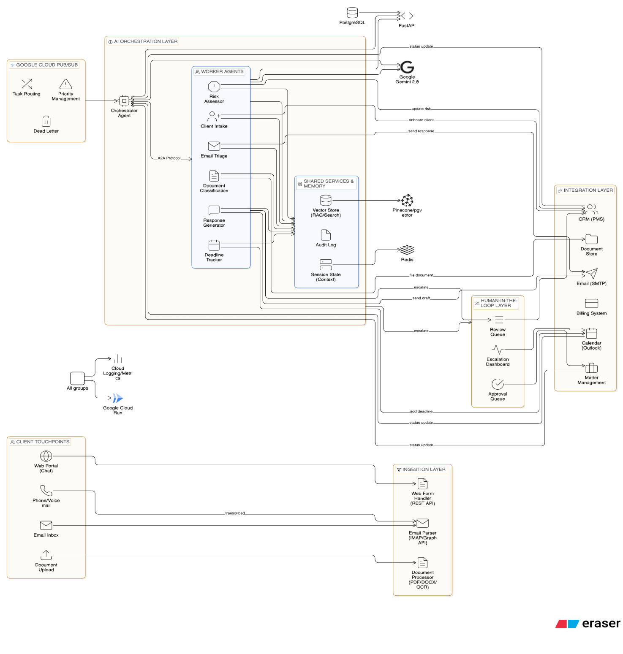
Charges only for actual compute time used
Flow diagram:
Technical Stack Overview:
AI Engine: Google Gemini Pro 2.0 powers all AI agents, providing advanced reasoning capabilities for legal document analysis, email classification, and response generation.
Message Queue: Google Cloud Pub/Sub handles parallel processing of multiple inputs (emails, calls, chats, documents), manages task routing to appropriate agents, and provides dead letter handling for failed task recovery.
RAG & Storage: Pinecone vector database stores embeddings for chats, emails, transcriptions, and documents enabling semantic search and retrieval. Redis handles chat session state caching for fast access.
Backend: Python FastAPI provides the REST API layer with async support for high concurrency. PostgreSQL database stores structured data including cases, clients, and agent outputs.
Hosting: Google Cloud Run (serverless) enables automatic scaling - spins up instances during high demand, scales to zero when idle, ensuring cost efficiency and infinite scalability.

5. Demo Application: Client Portal
The following screenshots demonstrate the working prototype of the BrightLaw A2A system. We start with the client-facing portal where communications are submitted.
Agentic system
Manages inputs
EMAIL + DOC
VOICE CALL
CHAT

5.1 Email Submission
Clients or staff can submit emails through the portal. The system captures sender details, subject, body, and any attachments. In this example, Emma Wilson is submitting a new company formation inquiry.
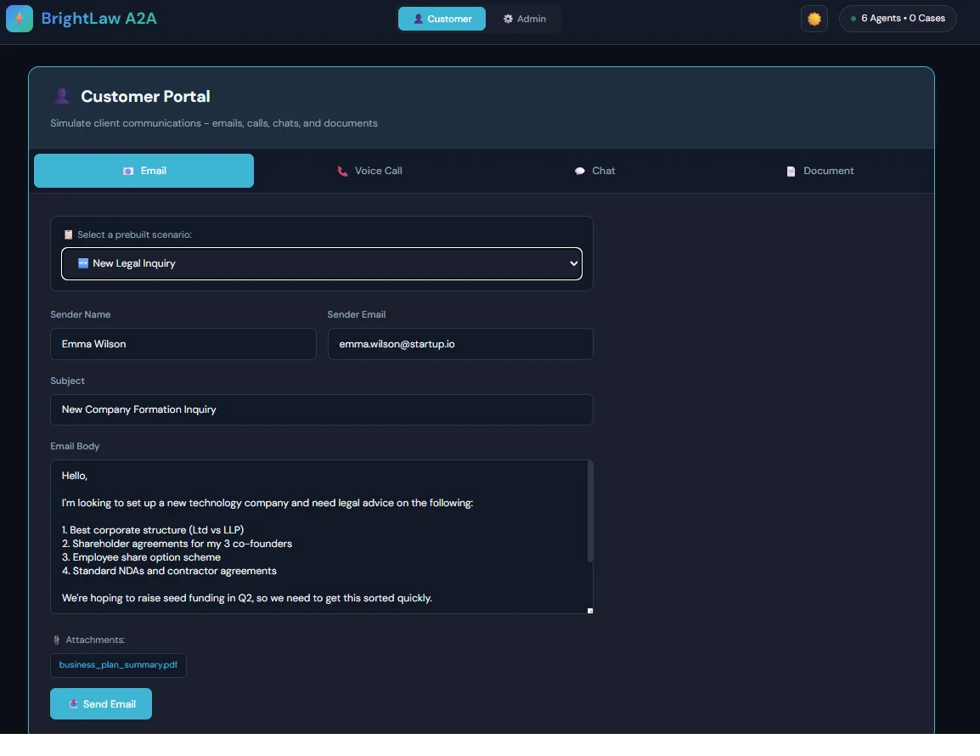
Figure 1: Client Portal - Email submission interface showing a new legal inquiry about company formation

5.2 Voice Call Submission
Phone calls are transcribed using speech-to-text technology and submitted for processing. The system captures caller details, phone number, call duration, and the full transcript. Here, Lisa Thompson is calling about divorce proceedings.
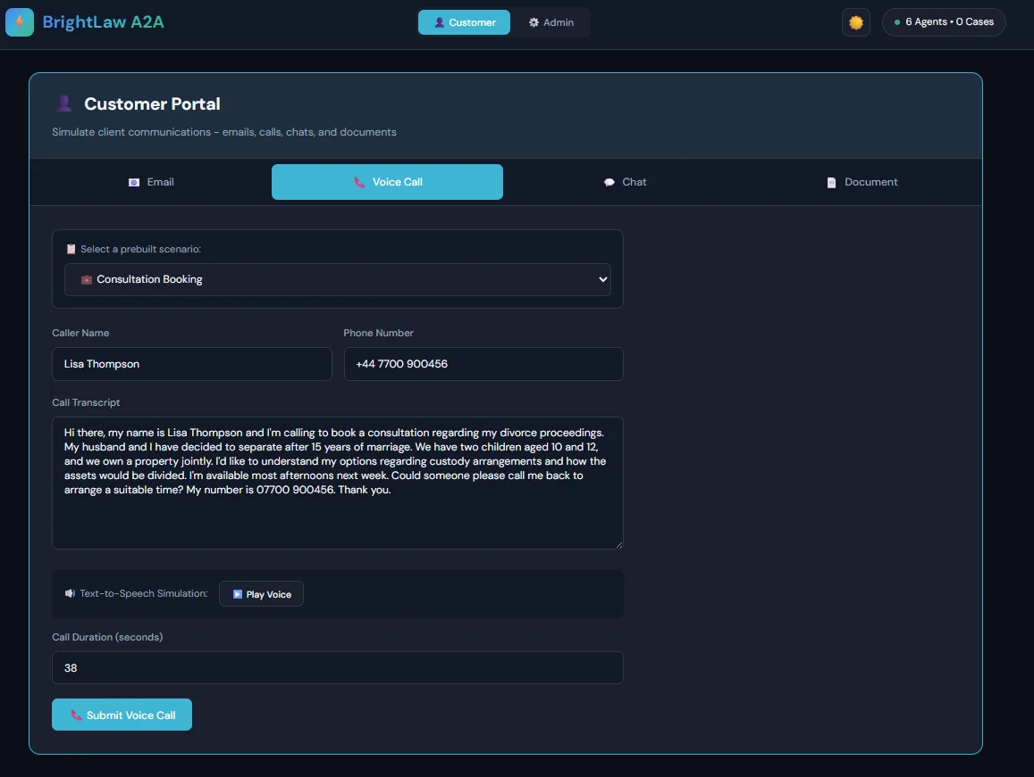
Figure 2: Client Portal - Voice call submission with transcribed content about family law consultation
5.3 Website Chat Submission
Live chat conversations from the firm's website are captured and analyzed. The chat transcript includes timestamps and identifies both visitor messages and bot responses. This example shows a landlord dispute inquiry.
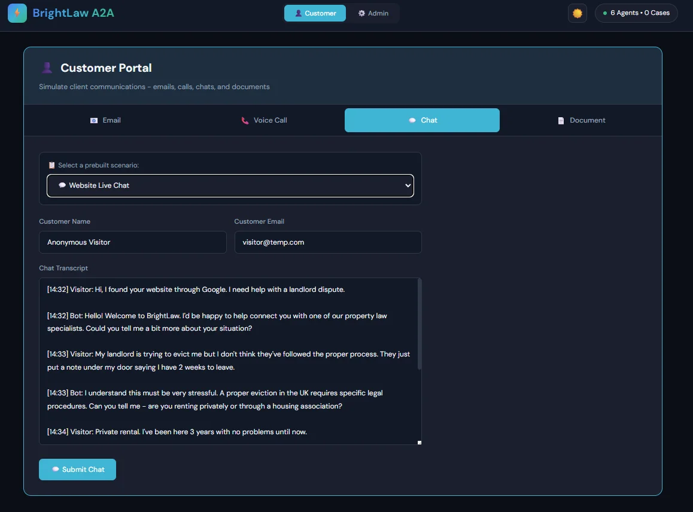
Figure 3: Client Portal - Website chat transcript showing a property law inquiry about eviction

5.4 Document Upload
Legal documents can be uploaded directly for classification and analysis. The system accepts various formats including DOCX and PDF. This shows an employment contract template being submitted.
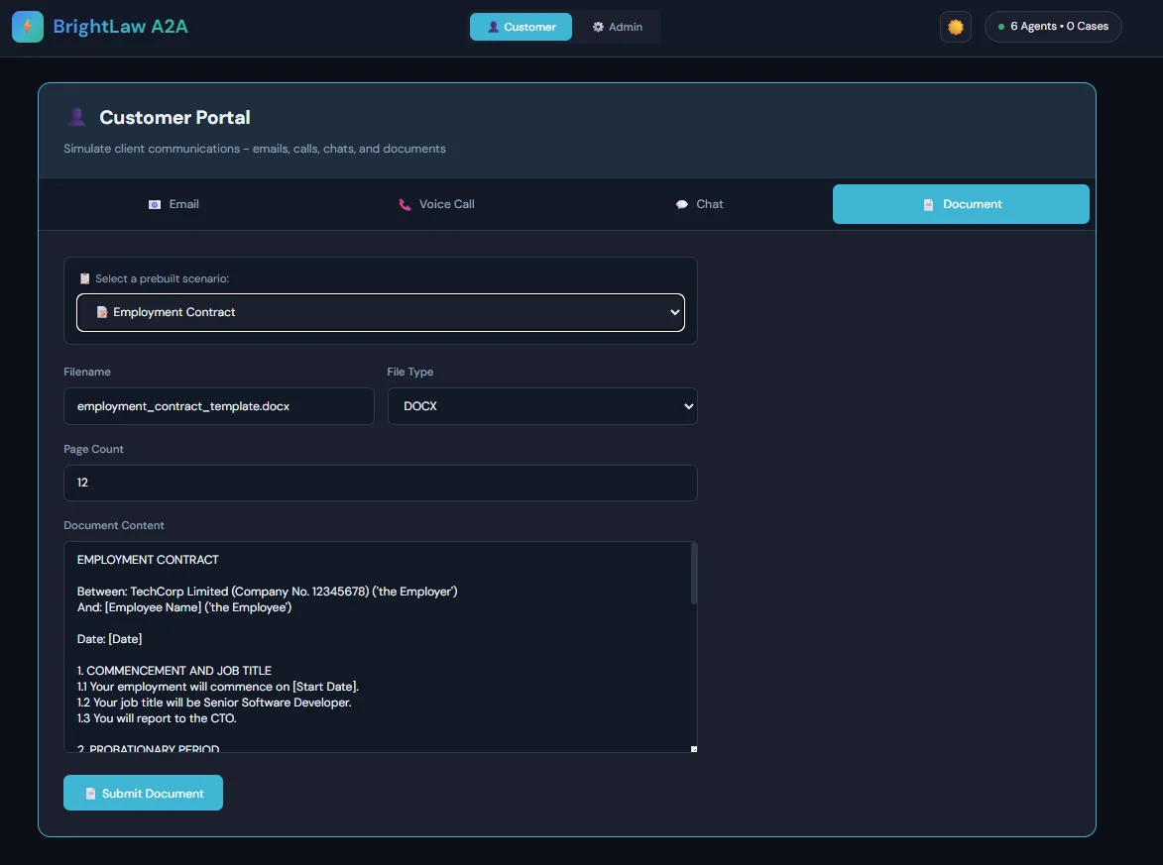
Figure 4: Client Portal - Document upload interface with an employment contract for analysis
5.5 What Happens After Submission
When any communication is submitted, it flows through the multi-agent workflow automatically:
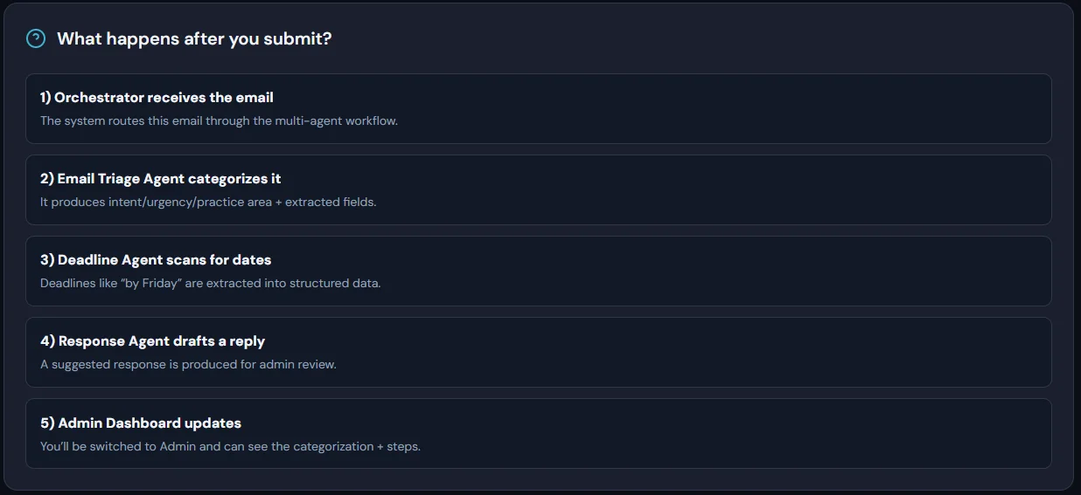
Figure 5: Workflow explanation showing the 5-step agent processing pipeline
The workflow consists of:
- Orchestrator receives the submission and routes it through the workflow
- Email Triage Agent categorizes it - determines intent, urgency, and practice area
- Deadline Agent scans for dates - extracts deadlines like "by Friday" into structured data
- Response Agent drafts a reply - produces a suggested response for admin review
- Admin Dashboard updates - the categorized case appears for lawyer review

6. Demo Application: Admin Console
The Admin Console is where lawyers and staff review the AI-processed cases. All communications are automatically sorted, classified, and presented with extracted information.

6.1 Dashboard Overview
The main dashboard shows total cases processed, broken down by type (emails, voice calls, chats, documents) and highlights cases that need human review. The yellow "Needs Review" counter (showing 2) indicates cases flagged for lawyer attention.
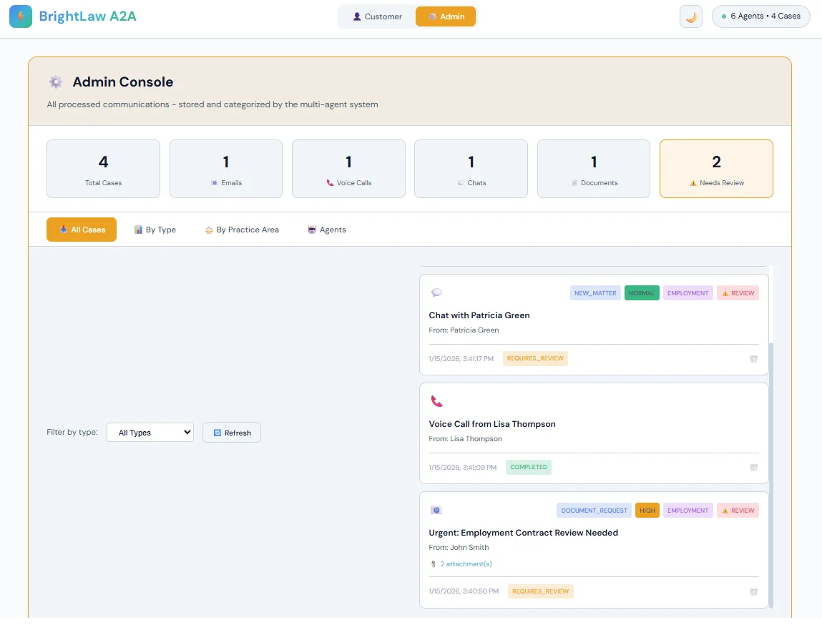
Figure 6: Admin Console Dashboard - Shows 4 total cases with breakdown by type and review status

6.2 Cases Sorted by Type
Cases can be filtered and viewed by communication type. Each case shows the source, timestamp, urgency level (HIGH, NORMAL), and processing status. This view helps staff quickly find specific types of communications.
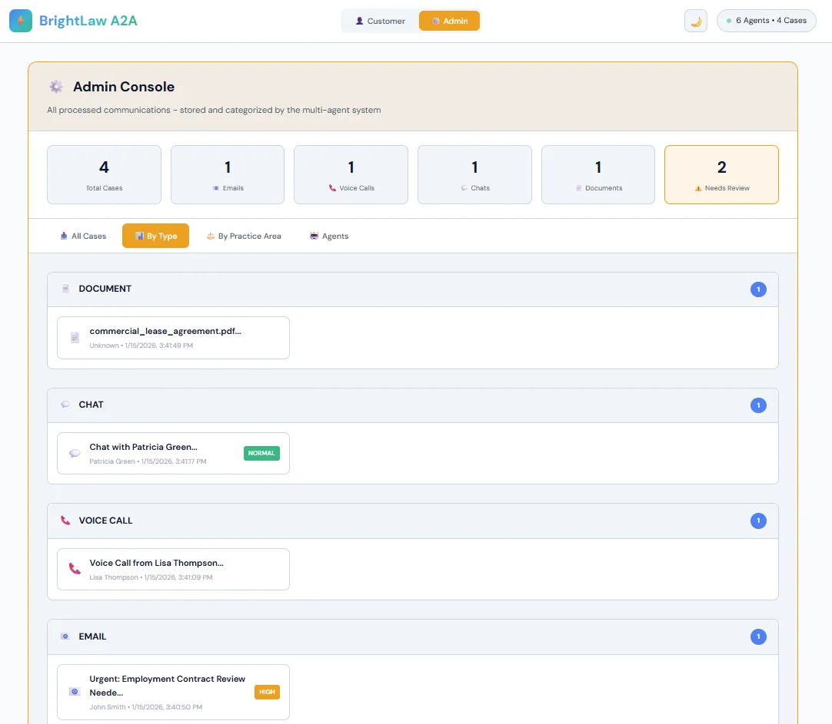
Figure 7: Admin Console - Cases organized by type showing documents, chats, voice calls, and emails

6.3 Registered Agents View
The Agents tab shows all six AI agents registered in the system, their capabilities, and typical processing times. This provides transparency into what each agent does and helps with system monitoring.
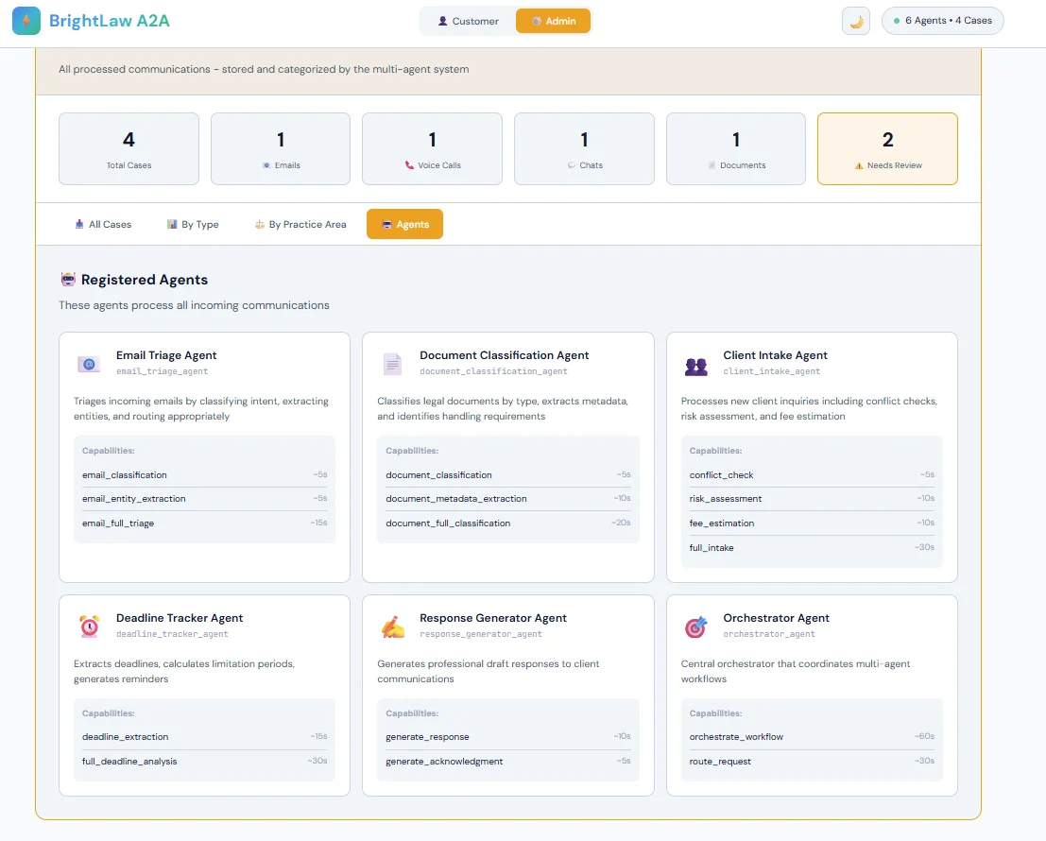
Figure 8: Admin Console - All 6 registered agents with their capabilities and processing times
The agents shown are:
- Email Triage Agent - Classifies emails (~5-15 seconds)
- Document Classification Agent - Analyzes documents (~10-20 seconds)
- Client Intake Agent - Processes new client inquiries (~10-30 seconds)
- Deadline Tracker Agent - Extracts and calculates deadlines (~15-30 seconds)
- Response Generator Agent - Drafts replies (~5-10 seconds)
- Orchestrator Agent - Coordinates all workflows (~30-60 seconds)

7. AI Document Analysis

7.1 Document Overview
When a document is processed, the AI extracts comprehensive information. This example shows a commercial lease agreement that was automatically analyzed.
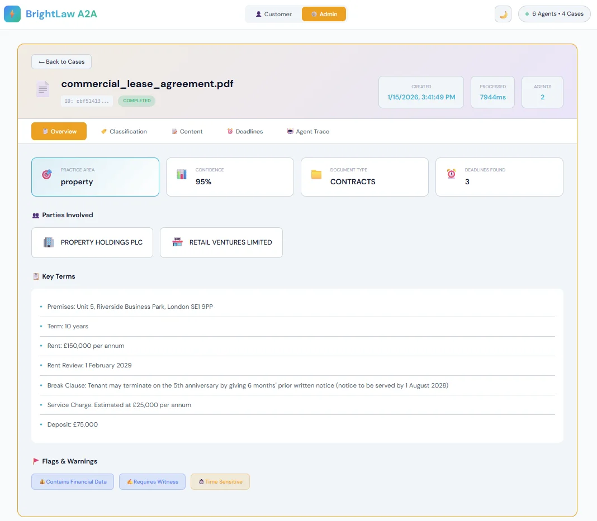
Figure 9: Document Analysis - Overview showing extracted practice area, confidence score, parties, and key terms
The AI automatically extracted:
- Practice Area: Property (95% confidence)
- Document Type: Contracts
- Parties: Property Holdings PLC and Retail Ventures Limited
- Key Terms: Premises location, 10-year term, £150,000 annual rent, rent review date, break clause details
- Flags: Contains Financial Data, Requires Witness, Time Sensitive
- Deadlines Found: 3 important dates extracted

7.2 Document Classification Detail
The Classification tab shows the AI's reasoning for its decisions. This transparency helps lawyers understand and verify the AI's analysis.
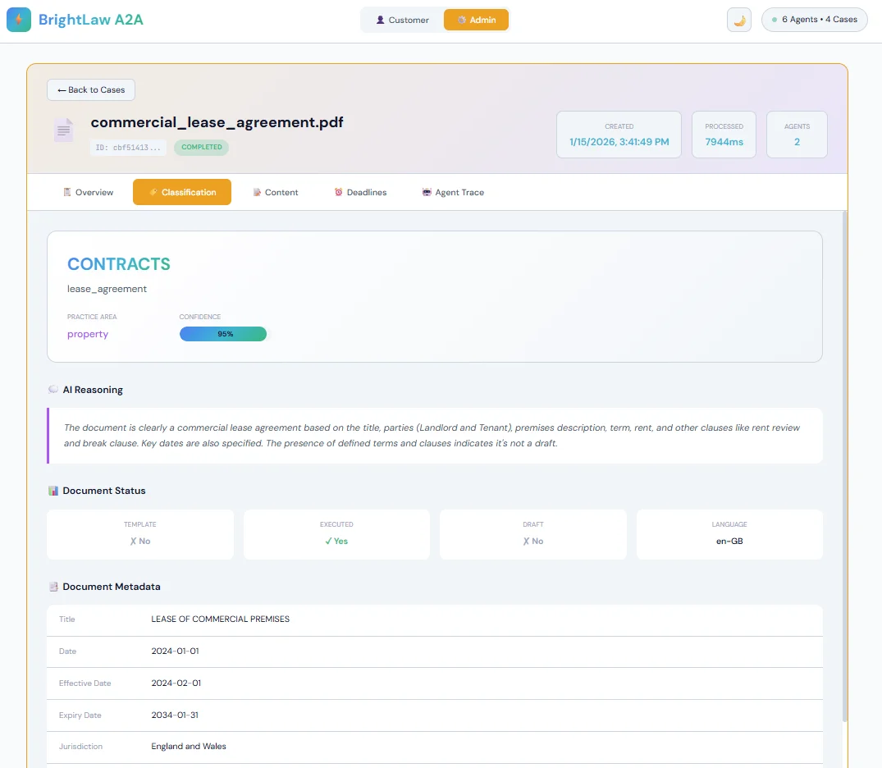
Figure 10: Document Classification - AI reasoning explaining why it identified this as a commercial lease
Key information shown:
- Document Type: CONTRACTS / lease_agreement
- Confidence: 95% (high confidence)
- AI Reasoning: Explains the classification based on title, parties, premises description, rent terms, and clauses
- Document Status: Not a template, Executed (signed), Not a draft, Language: en-GB
- Metadata: Title, dates (effective: 2024-02-01, expiry: 2034-01-31), jurisdiction (England and Wales)

8. AI Email Analysis

8.1 Email Classification
Emails are automatically classified with intent, practice area, urgency, and confidence scores. The AI also extracts key information and explains its reasoning.
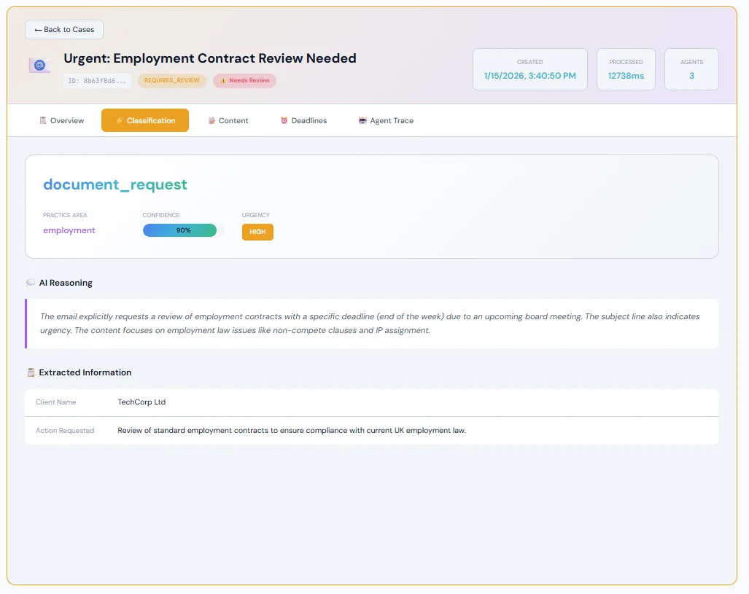
Figure 11: Email Classification - Urgent employment contract review request with AI analysis
This email was classified as:
- Intent: document_request (client is requesting document review)
- Practice Area: Employment
- Urgency: HIGH (deadline mentioned - end of week)
- Confidence: 90%
- Status: REQUIRES_REVIEW (flagged for lawyer attention)
The AI Reasoning explains: "The email explicitly requests a review of employment contracts with a specific deadline (end of the week) due to an upcoming board meeting. The subject line also indicates urgency. The content focuses on employment law issues like non-compete clauses and IP assignment."
Extracted Information:
- Client Name: TechCorp Ltd
- Action Requested: Review of standard employment contracts to ensure compliance with current UK employment law

9. Expected Results

9.1 Time Savings
Task | Manual Time | With AI | Saving
Email Processing | 7-9 min each | < 30 seconds | 95%+
Document Analysis | 1-2 hours | < 2 minutes | 98%+
Client Intake | 1-2 days | < 30 minutes | 95%+
Deadline Extraction | 30-60 min | < 1 minute | 98%+

9.2 Overall Impact
Metric | Before | After
Admin time per lawyer | 60% of day | 15% of day
Email response time | 24-48 hours | < 1 hour
Missed deadlines | 5-10 per month | Near zero
Client capacity | ~800 clients | 2000+ clients

9.3 Key Benefits
- Lawyers focus on legal work, not administration
- Faster client response times improve satisfaction
- No deadlines missed due to automated tracking
- Firm can grow without proportional staff increases
- 24/7 processing - no delays for out-of-hours inquiries
- Human oversight maintained - AI assists, lawyers decide

10. Conclusion
The Fescom AI Automation Platform demonstrates how multi-agent AI systems can transform legal services operations. By automating repetitive administrative tasks, lawyers are freed to focus on providing legal advice - the work that actually requires human expertise and judgment.
The key innovations in this solution are:
- Specialized AI agents for each task type, coordinated by an orchestrator
- RAG system to handle large documents despite AI context limitations
- Cloud-native architecture that scales automatically with demand
- Human-in-the-loop design ensuring lawyers maintain control
- Confidence scores and review flags for transparent AI decision-making
The working demo application shows the complete flow from client submission through AI processing to admin review. Documents are classified with 95% confidence, emails are triaged with extracted entities, and all cases are organized for efficient lawyer review.
This platform enables BrightLaw to scale from 800 to 2000+ clients while improving service quality and reducing response times by 95%. The future of legal services is human lawyers empowered by AI assistants - and this platform delivers that future today. BrightLaw is just an abstract pltform created to address this case study.

— End of Document —

